**Advanced Software Engineering**

**Lab10 Screenshots**

**Home Page**

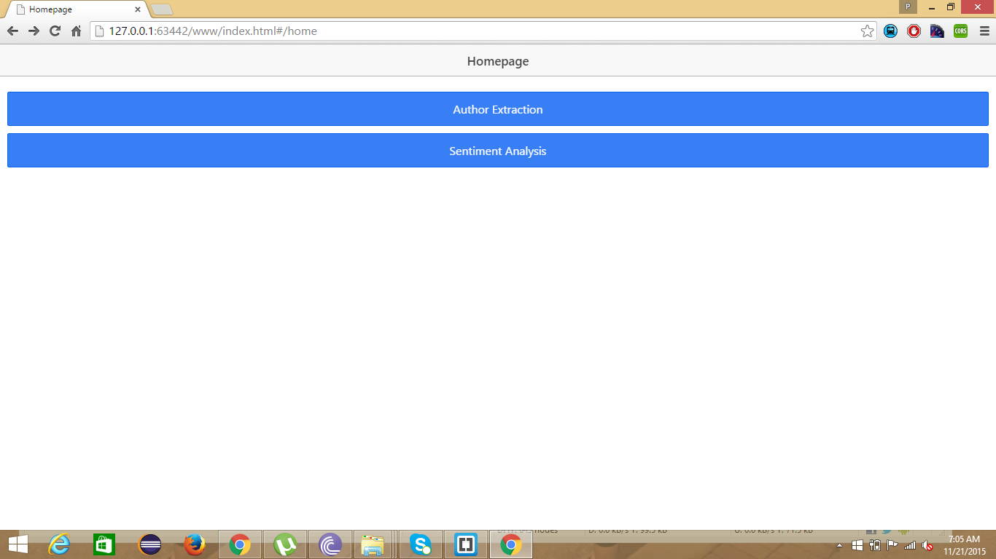

**Author Extraction:**

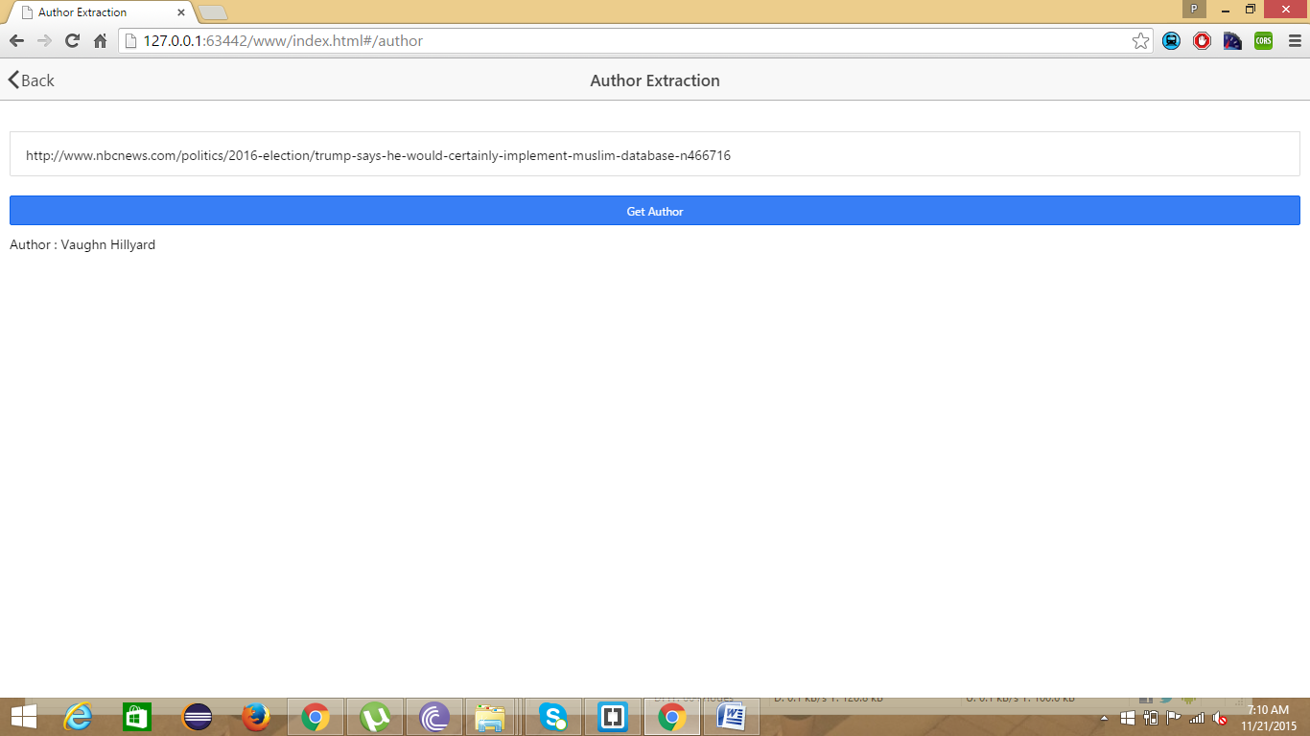

**Sentiment Analysis**

